The **Archive** and **Unarchive** options allow users to deactivate and reactivate records instead of deleting them permanently. This is useful for keeping the database clean while preserving historical data. Below is a step-by-step guide to implementing **Archive/Unarchive** functionality for a custom model in Odoo.

**Step 1: Add the active Field in Your Model**

By default, Odoo uses the active field (a boolean field) to handle the archiving mechanism. If a model doesn't have this field, you need to add it.

**Example: Adding active Field to Your Model**

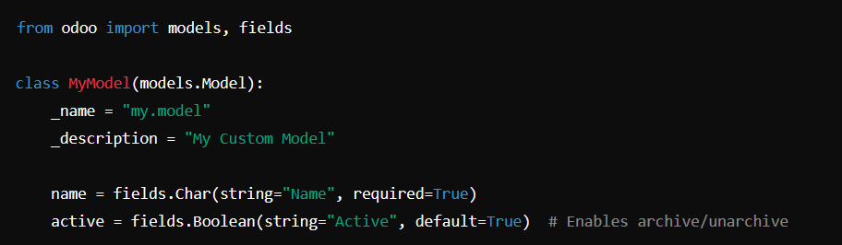

**Step 2: Modify the Tree and Form Views**

In the XML view file, ensure that Odoo recognizes the active field.

**Example: Adding Archive/Unarchive Support in Views**

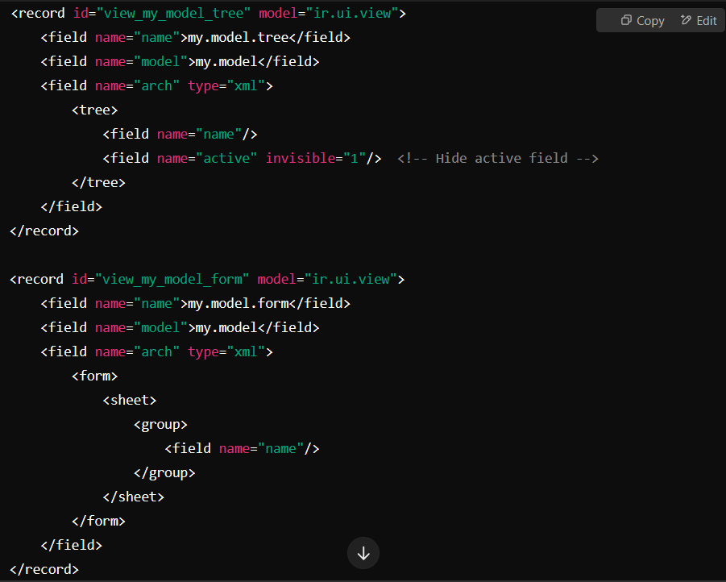

**Step 3: Ensure Archived Records Are Hidden by Default**

Archived records (where active = False) are hidden by default in Odoo. If you want to include them in your search view, you can modify your filter.

**Example: Adding Archived Filter Option**

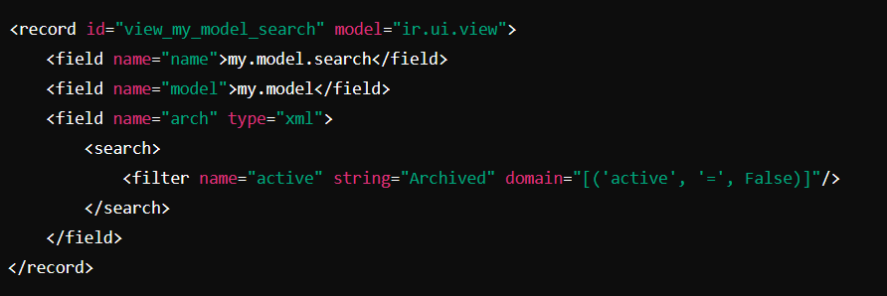

**Final Notes**

* Odoo automatically provides **Archive** and **Unarchive** options for models with an active field.
* You don't need to write custom actions unless you need specific behavior.
* Archived records are automatically filtered out from views but remain in the database.